UNITED STATES
SECURITIES AND EXCHANGE COMMISSION
Washington, D.C. 20549

FORM 6-K

Report of Foreign Private Issuer
Pursuant to Rule 13a-16 or 15d-16
of the Securities Exchange Act of 1934

Date of Report: September 14, 2026

Commission File Number: 001-39307

Legend Biotech Corporation
(Exact Name of Registrant as Specified in its Charter)

77 Corporate Drive
Bridgewater, New Jersey 08807
(Address of principal executive office)

Indicate by check mark whether the registrant files or will file annual reports under cover of Form 20-F or Form 40-F:

Form 20-F ☒ Form 40-F ☐

Legend Biotech Updates Clinical Pipeline

On September 14, 2026, Legend Biotech Corporation (the “Company”) made an updated clinical pipeline available on its website, as set forth in Exhibit 99.1 to this Form 6-K.

This report on Form 6-K, including the exhibits attached hereto, shall be deemed to be incorporated by reference in the registration statements of the Company on Form F-3 (Nos. 333-278050 and 333-257625) and Form S-8 (Nos. 333-239478 and 333-283217), to the extent not superseded by documents or reports subsequently filed.

EXHIBIT INDEX

Exhibit |  | Title
99.1 |  | Pipeline

SIGNATURES

Pursuant to the requirements of the Securities Exchange Act of 1934, the registrant has duly caused this report to be signed on its behalf by the undersigned, thereunto duly authorized.

LEGEND BIOTECH CORPORATION
(Registrant)

September 14, 2026 |  | By: |  | /s/ Alan Bash
 |  |  |  | Alan Bash
 |  |  |  | Interim Chief Executive Officer

Exhibit 99.1

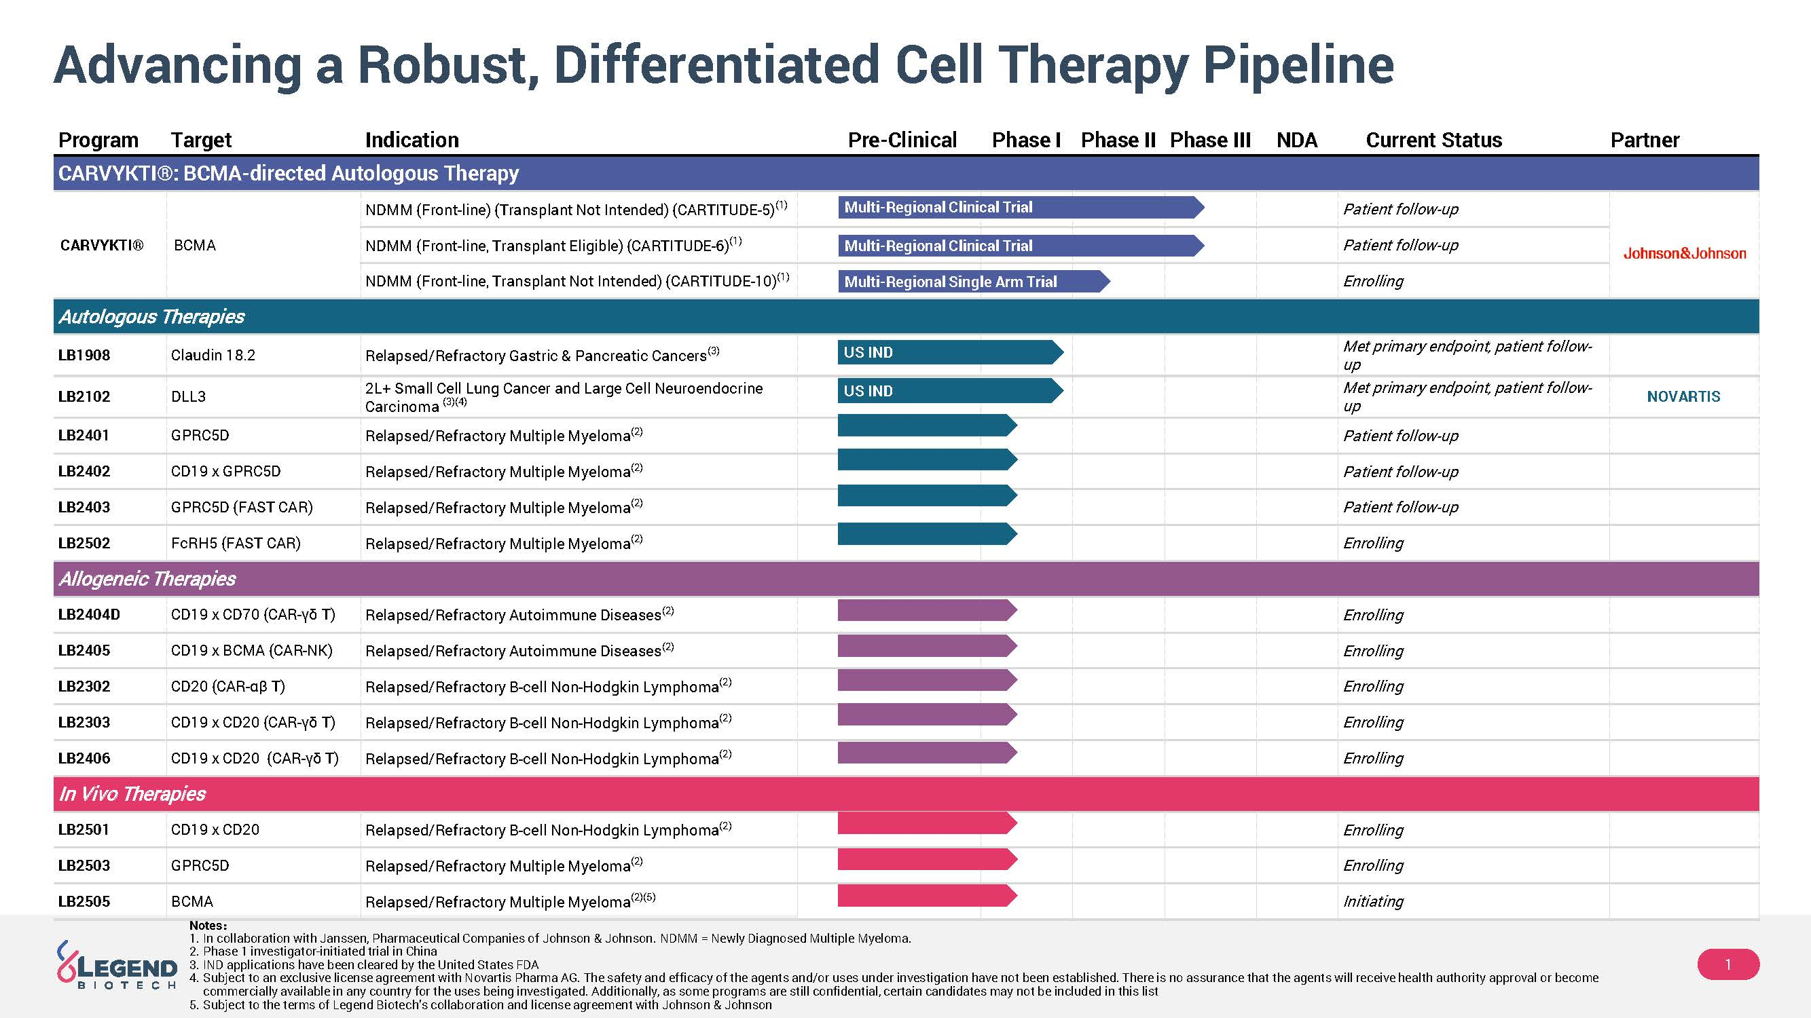
Advancing a Robust, Differentiated Cell Therapy Pipeline 1 Notes ： 1. In collaboration with Janssen, Pharmaceutical Companies of Johnson & Johnson. NDMM = Newly Diagnosed Multiple Myeloma. 2. Phase 1 investigator - initiated trial in China 3. IND applications have been cleared by the United States FDA 4. Subject to an exclusive license agreement with Novartis Pharma AG. The safety and efficacy of the agents and/or uses under in ves tigation have not been established. There is no assurance that the agents will receive health authority approval or become commercially available in any country for the uses being investigated. Additionally, as some programs are still confidential, ce rtain candidates may not be included in this list 5. Subject to the terms of Legend Biotech’s collaboration and license agreement with Johnson & Johnson Partner Current Status NDA Phase III Phase II Phase I Pre - Clinical Indication Target Program CARVYKTI®: BCMA - directed Autologous Therapy Patient follow - up NDMM (Front - line) (Transplant Not Intended) (CARTITUDE - 5) (1) BCMA CARVYKTI® Patient follow - up NDMM ( Front - line, Transplant Eligible) (CARTITUDE - 6) (1) Enrolling NDMM ( Front - line, Transplant Not Intended) (CARTITUDE - 10) (1) Autologous Therapies Met primary endpoint, patient follow - up Relapsed/Refractory Gastric & Pancreatic Cancers (3) Claudin 18.2 LB1908 NOVARTIS Met primary endpoint, patient follow - up 2L+ Small Cell Lung Cancer and Large Cell Neuroendocrine Carcinoma (3)(4) DLL3 LB2102 Patient follow - up Relapsed/Refractory Multiple Myeloma (2) GPRC5D LB2401 Patient follow - up Relapsed/Refractory Multiple Myeloma (2) CD19 x GPRC5D LB2402 Patient follow - up Relapsed/Refractory Multiple Myeloma (2) GPRC5D (FAST CAR) LB2403 Enrolling Relapsed/Refractory Multiple Myeloma (2) FcRH5 (FAST CAR) LB2502 Allogeneic Therapies Enrolling Relapsed/Refractory Autoimmune Diseases (2) CD19 x CD70 (CAR - γδ T) LB2404D Enrolling Relapsed/Refractory Autoimmune Diseases (2) CD19 x BCMA (CAR - NK) LB2405 Enrolling Relapsed/Refractory B - cell Non - Hodgkin Lymphoma (2) CD20 (CAR - αβ T) LB2302 Enrolling Relapsed/Refractory B - cell Non - Hodgkin Lymphoma (2) CD19 x CD20 (CAR - γδ T) LB2303 Enrolling Relapsed/Refractory B - cell Non - Hodgkin Lymphoma (2) CD19 x CD20 (CAR - γδ T) LB2406 In Vivo Therapies Enrolling Relapsed/Refractory B - cell Non - Hodgkin Lymphoma (2) CD19 x CD20 LB2501 Enrolling Relapsed/Refractory Multiple Myeloma (2) GPRC5D LB2503 Initiating Relapsed/Refractory Multiple Myeloma (2)(5) BCMA LB2505 Multi - Regional Clinical Trial Multi - Regional Clinical Trial US IND US IND Multi - Regional Single Arm Trial

